**Procedures to fix the https redirection error for Timetable Viewer**

**Table of Contents**

**Background** 1

**Impacted webpage** 1

**Solution** 1

**MS Edge** 1

**Chrome** 2

|  |  |  |  |
| --- | --- | --- | --- |
| **Version** | **Nature of changes** | **Changed By** | **Date** |
| 1 | Document created | Chen Huang | 14/12/2023 |
|  |  |  |  |
|  |  |  |  |
|  |  |  |  |
|  |  |  |  |
|  |  |  |  |
|  |  |  |  |

**Background**

People may accidentally unable to open the timetabling related webpages as below.

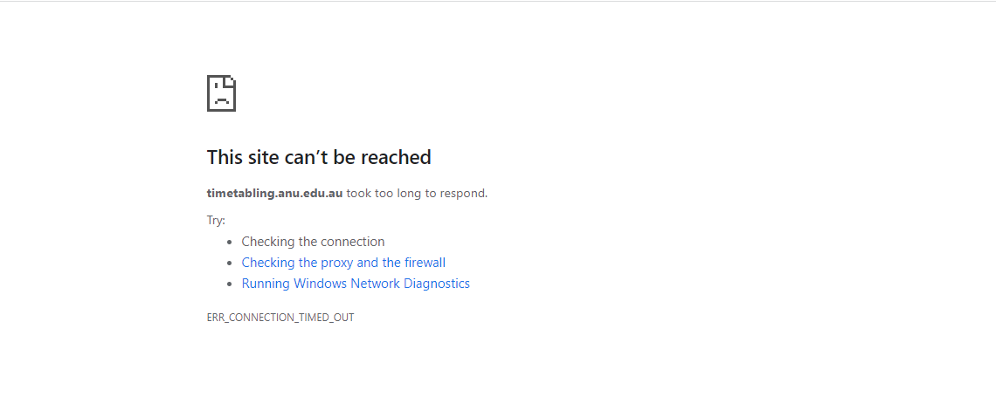

Or users may see a blank page when clicking on the View button.

**Impacted webpage**

* Timetable viewer

**Solution**

**MS Edge**

1. Click on the lock icon or ‘Not secure’ before the site address, normally at the place shown in the screenshot below.

1. Click on the ‘permissions for this site’, it will open a new tab showing the setting of the site.

1. Scroll down and find the ‘Insecure content’, change it to ‘Allow’.



1. Back to the Timetable Viewer page and click on ‘refresh’

**Chrome**

1. Click on the lock icon or ‘Not secure’ before the site address, normally at the place shown in the screenshot below.

1. Click on the ‘site setting’, it will open a new tab showing the setting of the site.

1. Scroll down and find the ‘Insecure content’, change it to ‘Allow’.



1. Back to the Timetable Viewer page and click on ‘refresh’