Procedures to fix the https redirection error for Timetable Viewer

Table of Contents
Background 1
Impacted webpage 1
Solution 1
MS Edge 1
Chrome 2

Version | Nature of changes | Changed By | Date
1 | Document created | Chen Huang | 14/12/2023

Background
People may accidentally unable to open the timetabling related webpages as below.
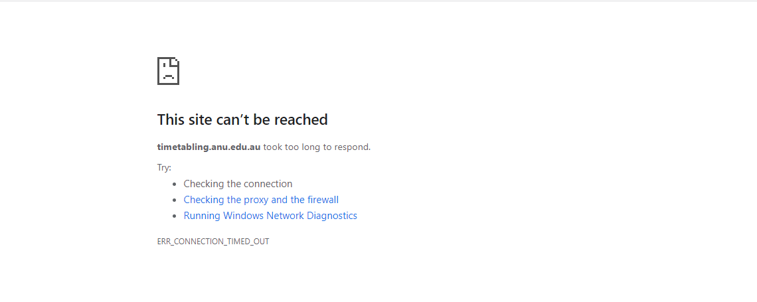
Or users may see a blank page when clicking on the View button.

Impacted webpage
- Timetable viewer

Solution

MS Edge
- Click on the lock icon or ‘Not secure’ before the site address, normally at the place shown in the screenshot below.
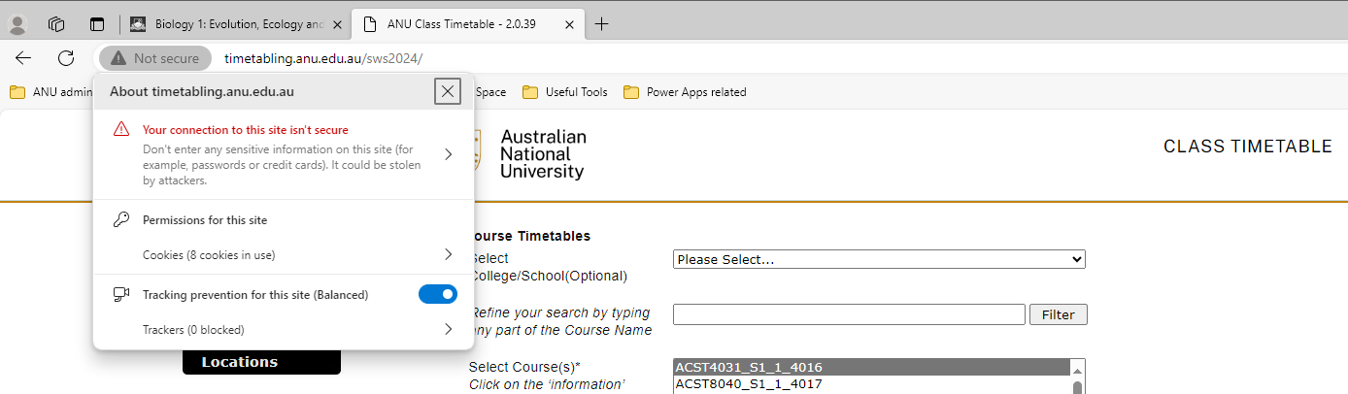
- Click on the ‘permissions for this site’, it will open a new tab showing the setting of the site.
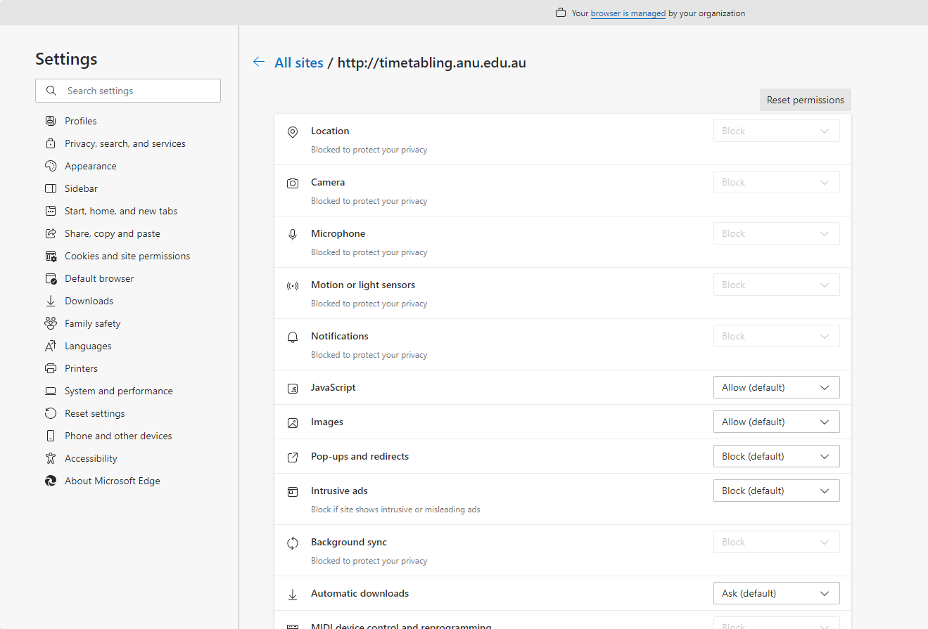
- Scroll down and find the ‘Insecure content’, change it to ‘Allow’.
- Back to the Timetable Viewer page and click on ‘refresh’

Chrome
- Click on the lock icon or ‘Not secure’ before the site address, normally at the place shown in the screenshot below.
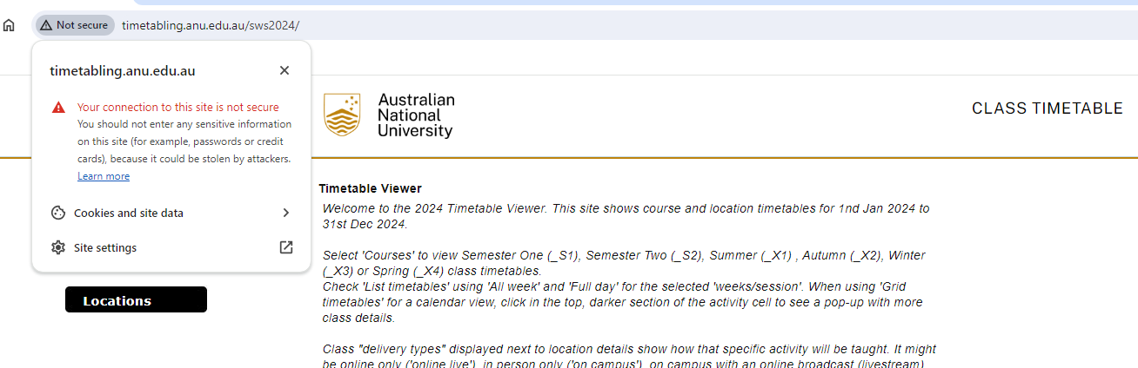
- Click on the ‘site setting’, it will open a new tab showing the setting of the site.
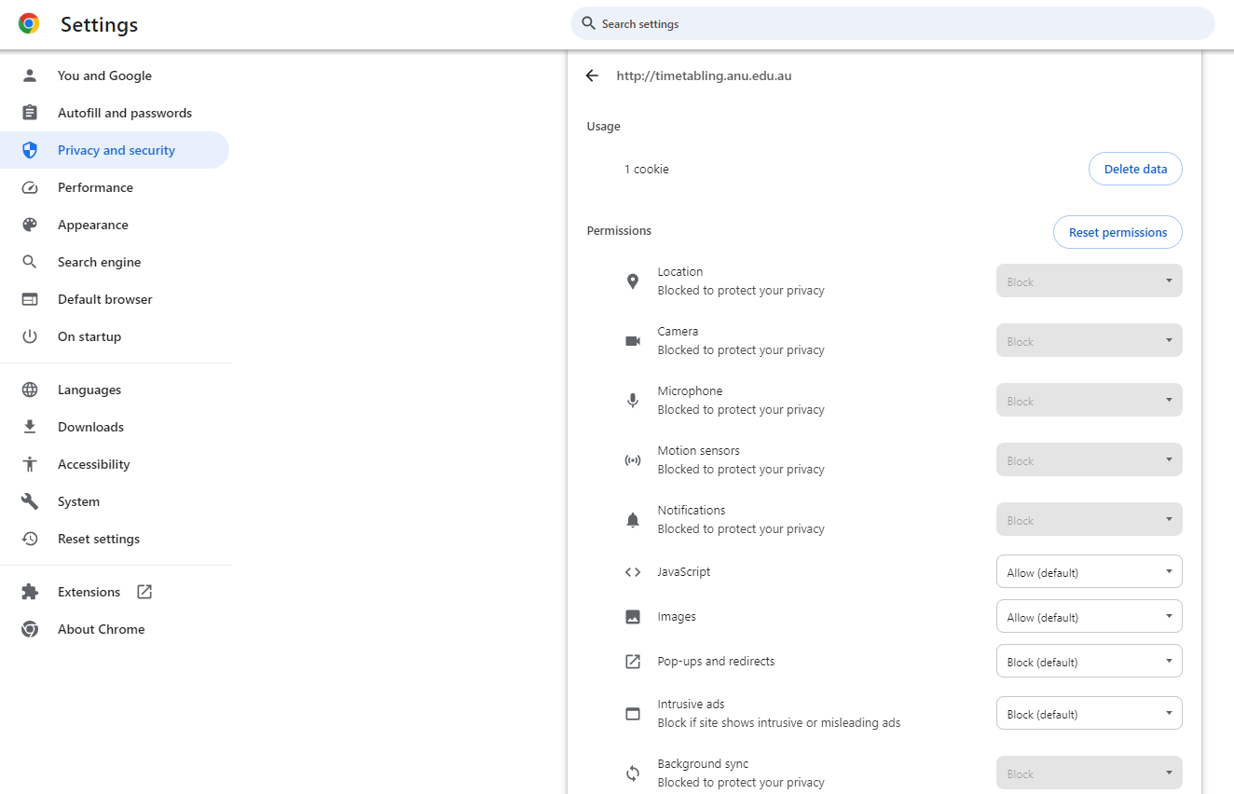
- Scroll down and find the ‘Insecure content’, change it to ‘Allow’.
- Back to the Timetable Viewer page and click on ‘refresh’

