ANU Class Timetables

A Guide for Students



ANU TIMETABLES WEBSITE

INSTRUCTION MANUAL & FREQUENTLY ASKED QUESTIONS GUIDE

This manual will guide you through the ANU Class Timetable website, and how to create a copy of a personalised class timetable.

CONTENTS

- Why use the ANU class timetables?
- How to do I construct a timetable using the timetable viewer?
- What do I do if I have multiple classes showing for one course? Do I have to attend all of them?
- What do I do if I have two courses with clashing class times?
- Help information

WHY USE THE ANU CLASS TIMETABLES?

At The Australian National University students have the opportunity to self-select courses that best suit them and their chosen Majors, Minors and/or Specialisations within their Program.

Provided you are choosing courses in order, with foundation courses before later year courses, and you are choosing courses that are available within your Program, your course choices are entirely your own.

The ANU Timetable Website can help you both before you have chosen courses and after you have chosen/enrolled in courses. You can:

- Make course decisions, by testing whether course times are clashing or on appropriate days/times for you to manage.
- Organise yourself once you have enrolled in your chosen courses.

Please note that the Timetabling website is for the purpose of view-only timetable information. If you need to retain this information for everyday use, please print your generated timetable after completing the below steps.

THE TIMETABLE VIEWER

To begin, go to the ANU Timetables website by selecting Current Students and then Timetable. Alternatively you can go directly to: http://www.anu.edu.au/students/program-administration/timetabling

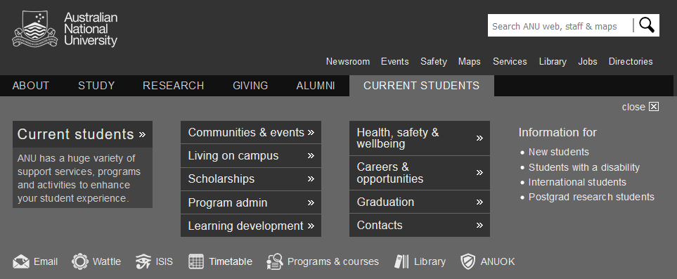

Click on the Timetable icon:

Click on the button “Visit Timetable Viewer”. Alternatively you can use the link in Step 1 under “HOW TO DO I CONSTRUCT A TIMETABLE USING THE ANU CLASS TIMETABLE VIEWER?”

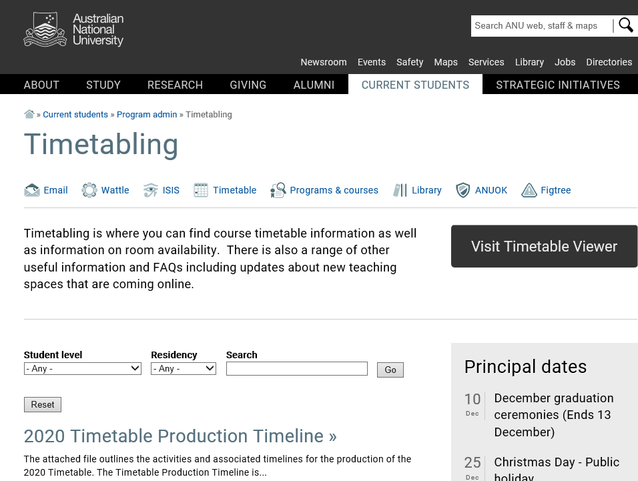
HOW TO DO I CONSTRUCT A TIMETABLE USING THE ANU CLASS
TIMETABLE VIEWER?

Step | Action
1 | Select the current Class Timetable from the ANU Timetables website:  http://timetabling.anu.edu.au/sws2020/  You will be re-directed to the ANU Timetable Viewer webpage.

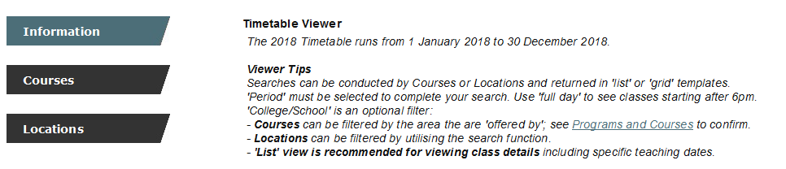

Step | Action
2 | Select the Courses tab to build a timetable of your courses.
3 | Select the courses you want to add to your timetable from the list at the ANU Class Timetable. You will also need to select the semester/session the courses are enrolled in and the days that you would like to appear on the timetable.  Note: to select multiple courses hold the CTRL or COMMAND key and select multiple courses.

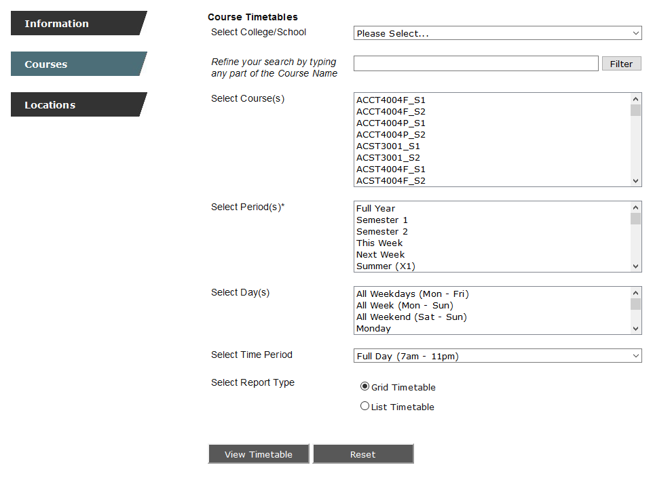

Step | Action
4 | Select Grid Timetable or List Timetable to choose the form you would like the timetable in and then select View Timetable.

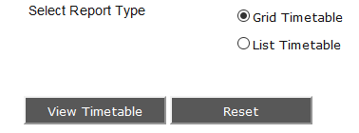

Your successful timetable will now appear. The courses will be listed, showing their lecture times and locations.

Step | Action
5 | The timetable will display the timetable broken into individual courses. You can merge your courses into one timetable or split it back into individual timetables by selecting the MERGE/SPLIT options on the top of the timetable.  Please note, in some cases only lectures and not tutorials are included in the ANU Class Timetable. In these cases your tutorials are likely to be announced in your first lecture.

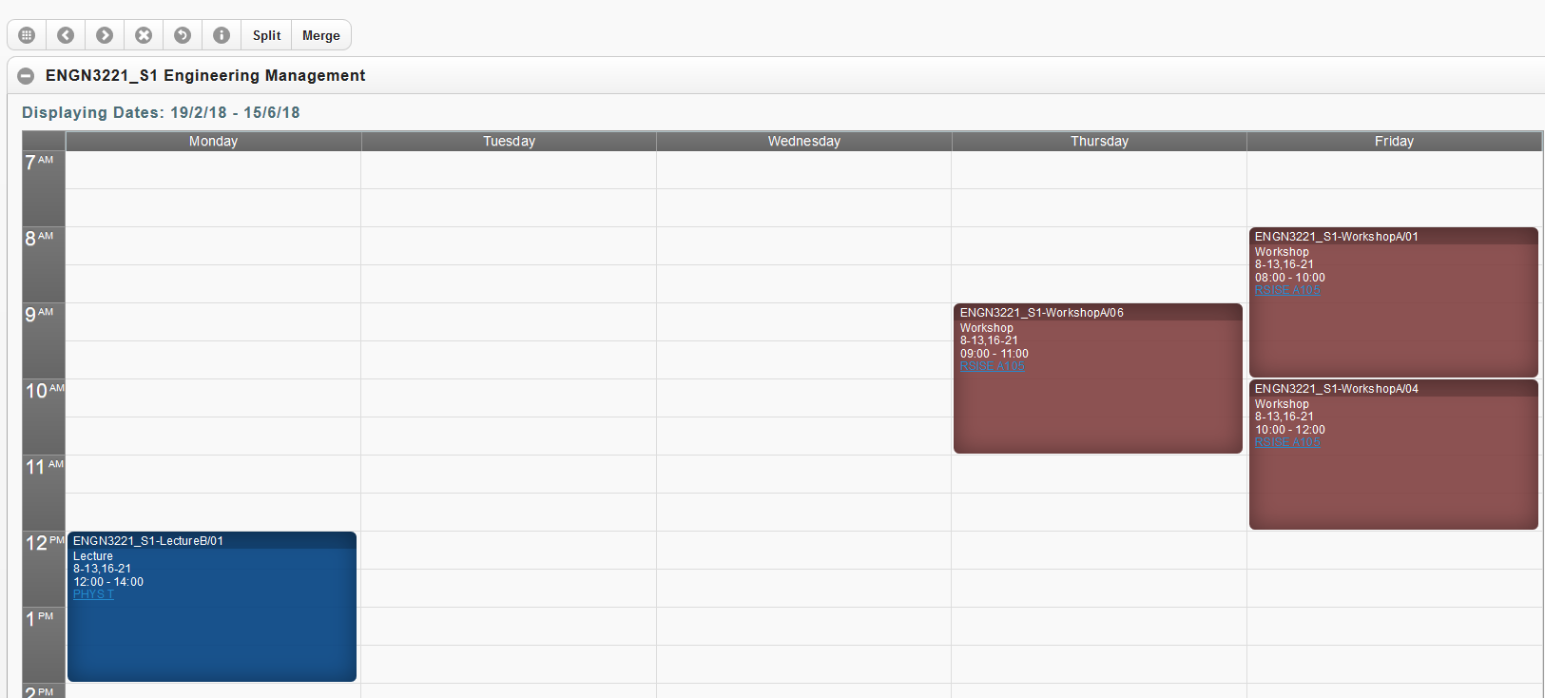

Your combined timetable will now appear. The courses will be listed, showing their lecture times and locations. Lectures, Seminars, Tutorials and Practicals will be listed in different colours on the timetables.

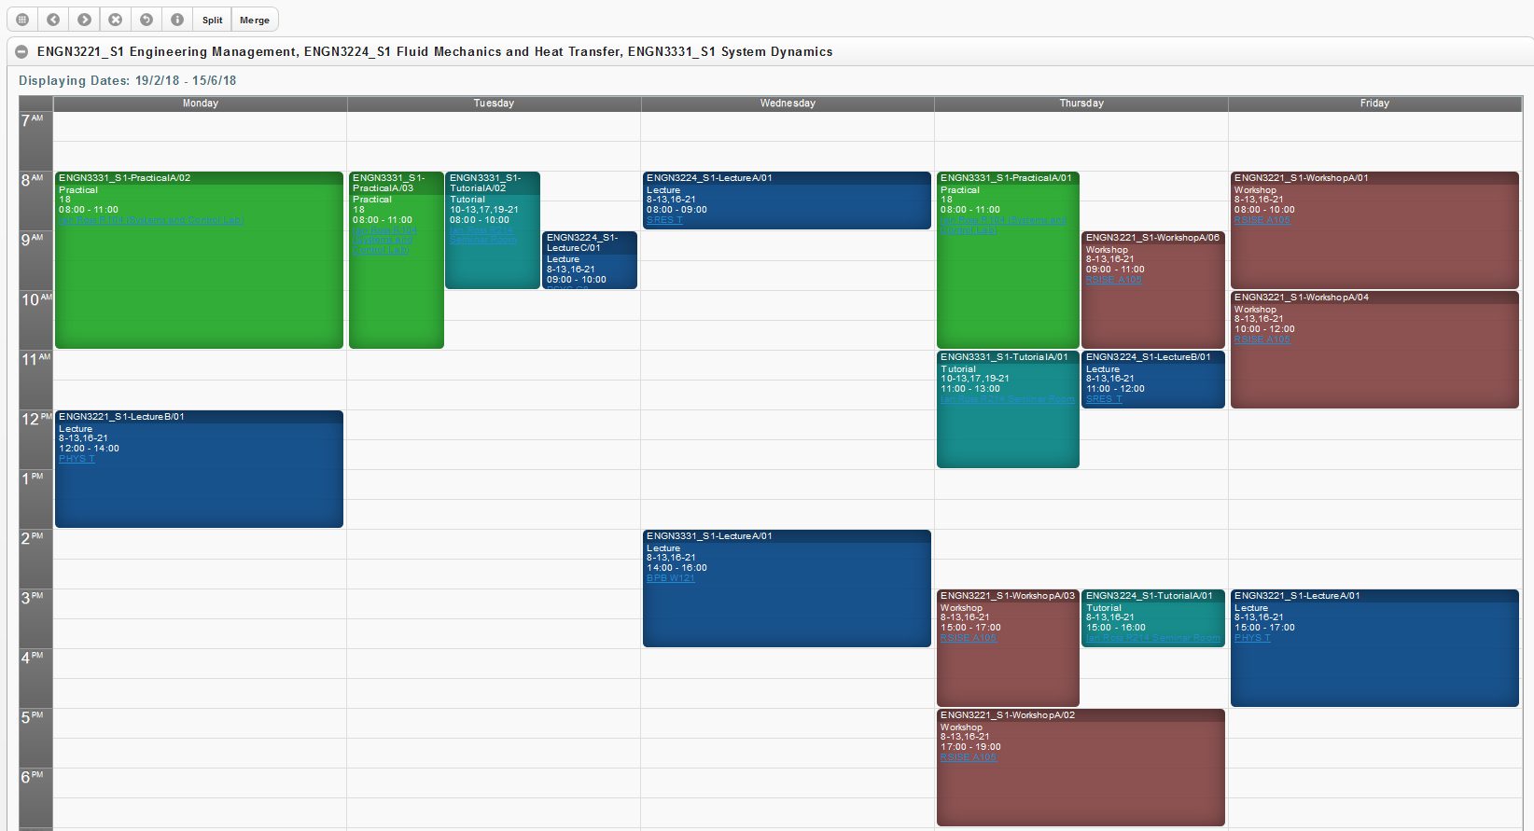

The timetable will list the name of the course, what type of class it is (lecture, tutorial, practical, seminar etc.), the weeks of the year that course runs, the time that it runs, and the location of the course.

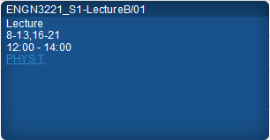

Step | Action
6 | To view your timetable in list view to see which weeks classes will run select the LIST TIMETABLE option when generating your timetable.

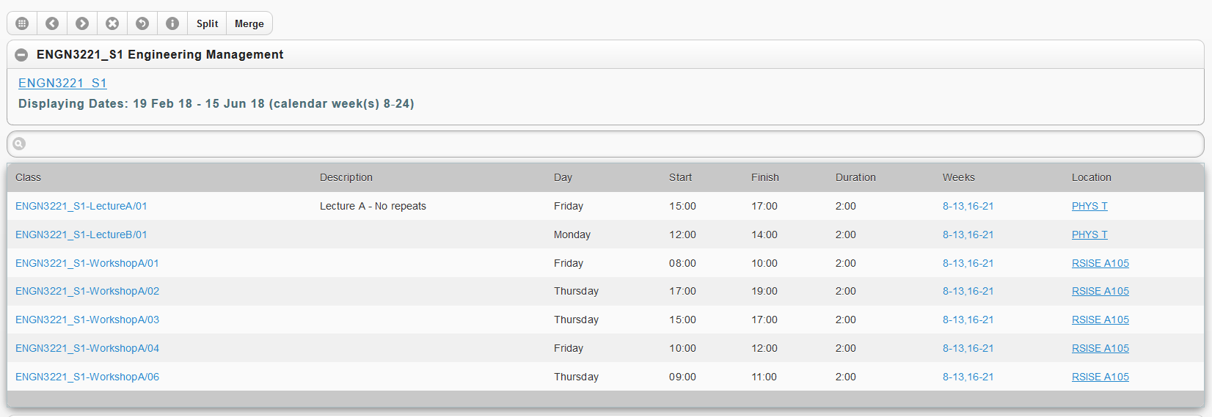

For further information on the Class Timetable you can select the Troubleshooting guide by selecting the “i” button at the top of the timetable.


WHAT DO I DO IF I HAVE MULTIPLE CLASSES SHOWING FOR ONE COURSE- DO I HAVE TO ATTEND ALL OF THEM?

Some courses in your timetable may have multiple classes listed. In some cases you may only be required to attend one or two of these classes each week. If you are unsure which classes you need to attend and which classes are optional, go to the first class listed in each course and check with the lecturer. Your lecturer will inform you which classes you must go to, and which classes aren’t required.

Some classes have more than one option to attend e.g. a Lecture or a Tutorial that has more than one ‘Group’ listed. Sometimes these classes are described as ‘Repeats’.
The following details the typical naming convention for classes and what it means for your attendance. Please note that there may be variations across schools so please refer to the course information and work load requirements found within Programs and Courses.

- Where the class name has a suffix containing an incremented letter e.g. LecA/01, LecB/01, LecC/01 this means you need to go to each of the classes. Typically these are Lectures but other activity types can have this structure.

- Where the class name has a suffix containing an incremented number e.g. TutA/01, TutA/02, TutA/03 this means you need to pick one activity only (as A/02 and A/03 are repeats of the content in A/01).

WHAT DO I DO IF I HAVE TWO COURSES WITH CLASHING CLASS TIMES?

If some of your courses have clashing class times, ask your lecturer if you need to attend those classes first.

If there is the option to sit the clashing classes online, or if they are only repeated lectures to accommodate a large class size, this may not cause you any problems.

If both face to face attendance at both classes are essential, however, you will need to make a decision about which course you would rather do more, and change your enrolment by choosing a different course for that semester.

If you do need to change your enrolment but are not certain which course to take instead, please consult with your Academic College Administration (contact details at back of this document) or check your Program Outline in Programs and Courses:

http://programsandcourses.anu.edu.au/

If you have already chosen new courses, and are ready to change your enrolment in ISIS, please be aware of any enrolment change deadlines and follow the enrolment instructions on the ANU Managing Your Program website:

http://www.anu.edu.au/students/program-administration/enrolment/changing-your-course
HELP INFORMATION

If you are receiving errors that are not addressed in this document please contact Student Central at student@anu.edu.au or on 135 ANU (135 268) for assistance.

ANU Academic College Contacts for Program and Course Advice

College of Asia and the Pacific
For both undergraduate and graduate students
Student Centre, ANU College of Asia and the Pacific
Room 7009, H C coombs building (9)
E: cap.student@anu.edu.au
T: 6125 3207

College of Arts and Social Sciences
Undergraduate: ug.students.cass@anu.edu.au
Graduate: graduate.students.cass@anu.edu.au

College of Business and Economics
For both undergraduate and graduate students: info.cbe@anu.edu.au

Colleges of Science
Undergraduate
The Science Office is located in Building 42A.
Appointments with Sub Deans are available Monday 10‐ 12, Tuesday 2‐ 4, Wednesday 10‐ 12, Thursday 2‐ 4 and Friday 10‐ 12. Appointments can be made in person at the reception desk or by emailing science.enquiries@anu.edu.au or phoning 6125 2809.

Graduate:
For Program and Course Advice please contact your program convener. If you are unsure who your program convener is email science.enquiries@anu.edu.au or phone 6125 2809.

College of Engineering and Computer Science
For both undergraduate and graduate students
CECS Student Services Office
N202, CSIT Building (108)
Email: studentadmin.cecs@anu.edu.au

ANU College of Law
Bachelor of Laws/Juris Doctor Program and Course Advice is available from the Sub-Dean,
E: Wayne.Morgan@anu.edu.au
T: (02) 6125 3483 to make an appointment

Graduate
Contact the ANU College of Law Student Administration on enquiries.law@anu.edu.au or telephone (02) 6125 3483 for specific program adviser contacts.

